Atkin’s Diet Plan and Crohn’s Disease
Name of Student
Name of Institution
Date
Topic: Atkins Diet
Part I, Criteria # 1: Identification of Nutrients
My patient’s name is C.J, who is a Caucasian female at the age of 30. She is also Jewish, 5’7” in height, weighs 135 lbs. and has two children. C.J works five days a week and is moderately active. She also has a history of Crohn’s disease. Her current diet is the Atkins diet, with additional consumption of 2 grams of sulfasalazine 3 times a day and 1000mg of calcium daily.
The Atkins diet comprises of low carbohydrates and high proportions of fats and proteins. A person under the diet typically consumes eggs, cheese, meat, and oils, but limits their intake of sugars, fruits, pasta, and bread (Odle & Davidson, 2013). The diet comprises four phases; induction, ongoing weight loss, pre-maintenance goal, and lifetime maintenance (Odie & Davidson, 2013). The first stage takes about two weeks, targeted at reducing weight. It requires the consumption of less than 20 net carbohydrates daily, between 12 and 15grams of low-carb vegetables. The duration also allows for unlimited quantities of fatty condiments, and liberal amounts of proteins.
The second stage commences after two weeks, strategic for an increase of five grams each week until the weight stalls, before resuming to the initial weight. Participants gradually induce nutrient-dense carbohydrates. Daily consumption of 25 grams of carbs is recommended for the first week, with the next recording 30 grams. The third stage gradually increases carbohydrate intake by 10 grams each week until weight loss stops. The participant drops to the previous intake of carbohydrates. Participants also include starchy vegetables, whole grains, and fruits in their diet. The final stage commences a month after the participants achieve their weight-loss goal. The stage recommends between 75-120 grams of carbohydrates in a day, which is subject to levels of activity, gender, and age (Odie & Davidson, 2013).
The phases provide clarity in the excessiveness of proteins (PRO) and also the deficiency of carbohydrates (CHO) in the diet. However, the maintenance phase on the fourth lifetime for the Atkins Diet notes a gradual increase in CHO, with between 75-120 grams. Cohen and the team stipulate that for the average American, their consumption of carbohydrates constitutes about 50% of their daily dose of calories (Cohen et al., 2015). The amount that equates to about 50% of calories from CHO intake is 250 grams when on a daily diet yielding 2,000 calories. The Institute of Medicine, National Academies of Science, recommends an acceptable AMDR which stipulates appropriate levels of calories from the diet for adults, that is, 45-65% from carbohydrates, 20-35% from fat, and 10-35% from proteins (Food and Nutrition Board, 2017).
Part I, Criteria #2: RDA Micronutrients
The National Institute of Health provides guidelines for the intake of salts and minerals for females (2017). The guidelines include 2600 mg/d for potassium, 1500 mg/d for sodium, 1000mg/d for calcium, 700 μg/d for vitamin A, 75mg/d for vitamin C, and 18mg/d of iron. Following the guidelines and adapting them to my client under My Fitness Pal, it is clear that C.J. has deficiencies in her intakes of all the above.
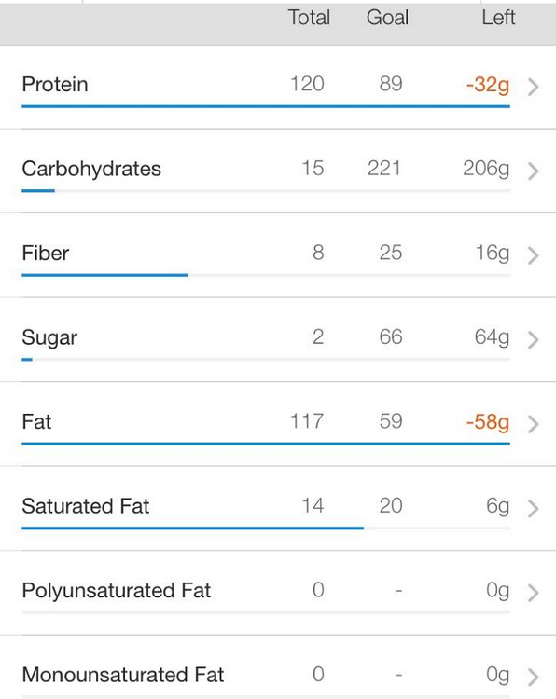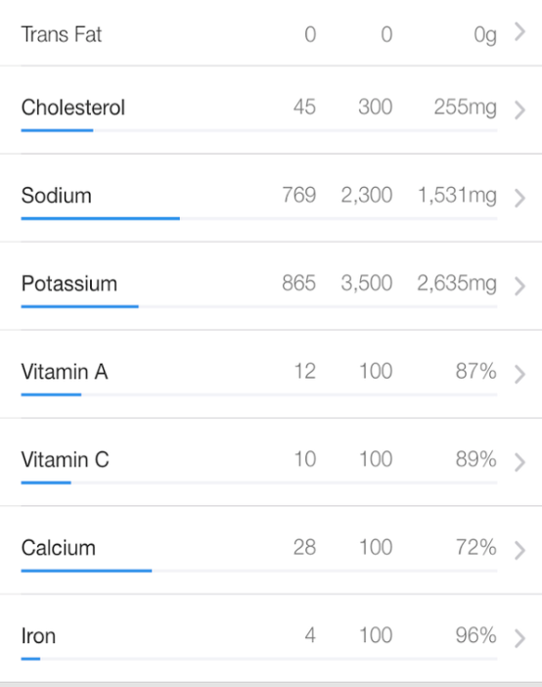
(MyFitnessPal.com, 2016)
Part II, Criterion #1: Disease Pathophysiology Affected by Diet
Crohn’s is a chronic illness with traits of inflammation in the intestinal tract, which could be ulcerated. The typical patient diagnosed with Crohn’s is one with high consumption of refined sugar in comparison with healthy individuals, but also consumes fiber, vegetable and raw fruit in fewer quantities (Ronzio, 2017). Calcium and iron deficiencies bring about the symptoms of the disease. Crohn’s disease is yet to have a cure through drugs, but can be managed through diet and steroids.
If C.J were to currently be diagnosed with Crohn’s disease, the Atkins diet would further irritate her intestinal tract because the Atkins diet is very high in fat. Irritable bowel disease (IBD) is mainly associated with diet and gut microflora. Meal plans with high consumption levels of animal fats and proteins could effectively reduce the amount of bacteria that prove beneficial in the intestine (Chiba et al., 2016). The range of nutrients appropriate for consumption by C.J should be appropriately wide to promote mitigating the effects of the disease in the small intestine (Ronzio, 2017). The consumption should incorporate folic acid, zinc, and amino acid glutamine, which improves digestion while decreasing intestinal inflammation (Ronzio, R., 2017). Acceptable foods include bananas, soy, tofu, fish, white rice, oatmeal, sourdough, cucumbers, and potatoes (Crohn’s & Colitis Foundation, 2019).
Part II, Criterion #2: Food and Medication
C.J consumes 2 grams of sulfasalazine thrice a day and 1000 mg of calcium daily. Sulfasalazine may decrease iron absorption and folic acid absorption (Sanoski & Vallerand, 2014). It is recommended that the patient take this medication with food to avoid upset stomach (Sanoski & Vallerand, 2014). High amounts of calcium can also interfere with mineral absorption, including iron absorption, as well as zinc which promotes gut healing (Davidson & Alic, 2017). An acceptable Calcium intake for C.J is 1000 mg/day, which is the dose that she is currently taking (Davidson & Alic, 2017). Both sulfasalazine and calcium aim to control the progression of Crohn’s disease and the severity of the symptoms.
Part III, Criterion #1: BMI, BMR, CHO, PRO for C.J
Height = 67 inches = 1.7018 meters (2.896 m²)
Weight = 61.4 kgs
BMI = ${61.4 kgs}/{2.896 m^{2}}$ = 21.2
C.J is a30-year-old Caucasian female who is Jewish, 5’7” in height (67 inches), weighs 135 lbs (61.4 kg). C.J’s BMI is 21.2, which is considered to be normal. Her rate of calorie consumption from her BMR is 1992 calories per day since she is moderately active.
BMR = (10 × weight in kg) + (6.25 × height in cm) – (5 × age in years) + 5
= $\left(10 × 61.4\right)+ \left(6.25 ×170.18\right)- \left(5 ×30\right)+ 5$
= 1532
Calorie count = 1532 × 1.3 = 1992
Borrowing from the National Institute of Medicine, National Academies of Science recommend an acceptable AMDR; it is probable to calculate from the calorie count the advisable amount of consumption for C.J.
CHO = (1992 × 0.45)/ 4 calorie per gram = 224 grams
CHO = (1992 × 0.65)/ 4 calorie per gram = 324 grams
PRO = 0.8 × (weight in Kilograms)
= 0.8 × 61.4 = 49 grams
Fat = (1992 × 20) divide by 9 calories/gram = 44
Fat = (1992 × 35) divide by 9 calories/gram = 77
To maintain her current healthy weight, it is recommended that C.J. consumes 224-324 grams of CHO, 49 grams of PRO, and 44-77 grams of fats.
Part III, Criterion #2: Nutritional Education Plan with SMART Goals
Having a history of Crohn's disease, C.J should be educated on eating every 3-4 hours, and the significance of ensuring that throughout the day she remains hydrated. During remission, the inclusion of a wide range of fruits and vegetables, and whole grains in her meal if wise for C.J (Crohn's Disease and Diet, 2017). It is also highly recommended for patients to retain a food log that identifies foods that either improve or worsen their symptoms of the disease (Crohn's & Colitis Foundation, 2019). In addition, C.J should be informed about foods and extracts from plants that promote and increase quantities of bacteria in the gut that prove beneficial (Chiba et al, 2016). With this in mind, a semi-vegetarian diet would be encouraged, which includes additional servings of white meat, such as fish, once in a week and also red meat once every 2 weeks" (Chiba et al., 2016). In a study, more than 50% of patients diagnosed with ulcerative colitis experienced an improvement in symptoms. They also decreased the amount of fecal occult blood without medication while following the semi-vegetarian diet (Chiba et al., 2016). Since C.J is a mother of two and works full time, it would be encouraged for her to meal prep for lunch at work and pack nutritious snacks to eat throughout the day, such as almonds, cut veggies, or yogurt.
- SMART goal #1: Patient will download a food tracking app
- SMART goal #2: Patient will consume 2-3 liters of water within the 12 hours shift today.
- SMART goal #3: Patient will verbalize one important benefit of consuming fiber in diet after nutritional education today.

References
Atkins Diet: What’s behind the claims? (2017). Retrieved from Mayo Clinic website: https://www.mayoclinic.org/healthy-lifestyle/weight-loss/in-depth/atkins-diet/art-20048485
Chiba, M., Tsuda, S., Komatsu, M., Tozawa, H., & Takayama, Y. (2016). Onset of Ulcerative Colitis during a Low-Carbohydrate Weight-Loss Diet and Treatment with a Plant-Based Diet: A Case Report. The Permanente journal, 20(1), 80–84. doi:10.7812/TPP/15-038
Cohen, E., Cragg, M., deFonseka, J., Hite, A., Rosenberg, M., & Bin Zhou. (2015). Applied nutritional investigation. Statistical review of US macronutrient consumption data, 1965-2011: Americans have been following dietary guidelines, coincident with the rise in obesity. Nutrition, 31(5), 727–732. https://doi-org.westcoastuniversity.idm.oclc.org/10.1016/j.nut.2015.02.007
Crohn’s & Colitis Foundation. (2019). What should I Eat? Retrieved from Crohn’s & Colitis Foundation website: https://www.crohnscolitisfoundation.org/diet-and-nutrition/what-should-i-eat
Crohns Disease and Diet. (2017). Retrieved from Eatright.org website: https://www.eatright.org/health/wellness/digestive-health/crohns-disease-and-diet
Davidson, T., &Alic, M. (2017). Calcium. In Gale (Ed.), Gale virtual reference library: The Gale encyclopedia of nutrition and food labels. Farmington, MI: Gale. Retrieved from https://westcoastuniversity.idm.oclc.org/login?url=https://search.credoreference.com/content/entry/galegnafl/calcium/0?institutionId=8049
Food and Nutrition Board, Institute of Medicine, National Academies of Sciences. (2017). Dietary Reference Intakes: EAR, RDA, AI, Acceptable Macronutrient Distribution Ranges, and UL. http://www.umich.edu/~exphysio/mvs.241/RI.macronutrients.pdf
MyFitnessPal.com. (2016). Free Calorie Counter, Diet & Exercise Journal. Retrieved from Myfitnesspal.com website: https://www.myfitnesspal.com/food/diary
MyPlate Plan | ChooseMyPlate. (2019). Retrieved from Choosemyplate.gov website: https://www.choosemyplate.gov/resources/MyPlatePlan
National Institutes of Health (2017). Retrieved from Nih.gov website: https://ods.od.nih.gov/Health_Information/Dietary_Reference_Intakes.aspx
Odle, T., & Davidson, T. (2013). Atkins Diet. In K. Key (Ed.), The Gale encyclopedia of diets: a guide to health and nutrition (2nd ed.). Farmington, MI: Gale. Retrieved from https://westcoastuniversity.idm.oclc.org/login?url=https://search.credoreference.com/content/entry/galediets/atkins_diet/0?institutionId=8049
Ronzio, R. (2017). Crohn's disease and diet. In R. Ronzio, Facts on File library of health and living: The encyclopedia of nutrition and good health (3rd ed.). New York, NY: Facts On File. Retrieved from https://westcoastuniversity.idm.oclc.org/login?url=https://search.credoreference.com/content/entry/fofnagh/crohn_s_disease_and_diet/0?institutionId=8049
Sanoski, C. A., & Vallerand, A. (2014). Sulfasalazine. In J. H. Deglin, & A. H. Vallerand, Davis's drug guide for nurses (14th ed.). Philadelphia, PA: F.A.Davis Company. Retrieved from https://westcoastuniversity.idm.oclc.org/login?url=https://search.credoreference.com/content/entry/fadavisdrug/sulfasalazine/0?institutionId=8049

